Game Design Document

Fill up the following document

1. Write the title of your project.

Fighter plane game

1. What is the goal of the game?

To destroy all the aliens and free the space

1. Write a brief story of your game.

There is one fighter plane which is sended in space

to destroy aliens and free the space

1. Which are the playing characters of this game?

* Playing characters are the ones who respond to the user based on the input from the user.
* Cars, monkeys, dinos, wizards, etc., are the playing characters in the game.

|  |  |  |
| --- | --- | --- |
| Number | Character Name | What can this character do? |
| 1 | Fighter plane | Have missiles and gun to destroy asteroids and aliens |
| 2 |  |  |
| 3 |  |  |
| 4 |  |  |
| 5 |  |  |
| 6 |  |  |
| 7 |  |  |
| 8 |  |  |

1. Which are the Non-Playing Characters of this game?

* Non-Playing characters are the ones that don't have an action or behavior when the user interacts with the game.
* Hurdles, stones, bananas, coins, etc., are non-playing characters in the game.

|  |  |  |
| --- | --- | --- |
| Number | Character Name | What can this character do? |
| 1 | Asteroids | Can damage fighter plane and detroy fighter plane |
| 2 | Aliens | Can destroy fighter plane |
| 3 |  |  |
| 4 |  |  |
| 5 |  |  |
| 6 |  |  |
| 7 |  |  |
| 8 |  |  |

Draw your imagination of this game. What does this game look like?

* Draw the game either on your computer or on paper.
* Add images of the game scenes to show each of the playing and non-playing characters at least once.

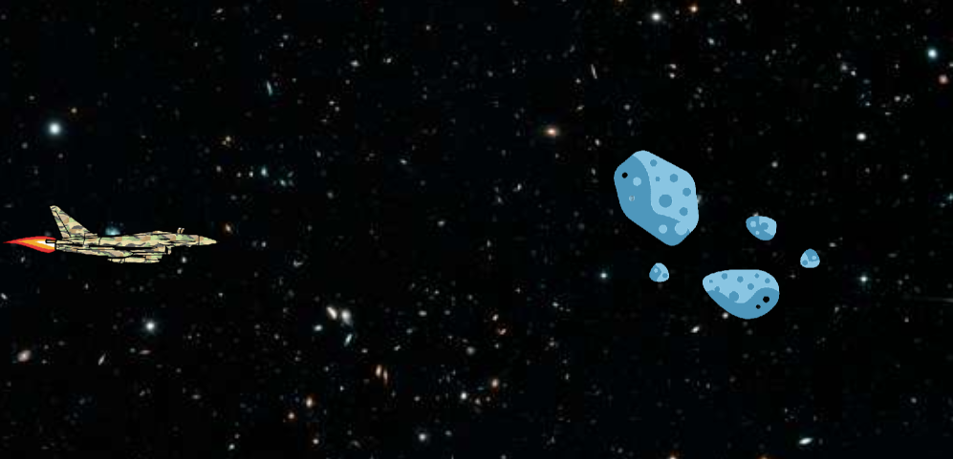

How do you plan to make your game engaging?

I will add wepon to fighter plane that will destroy the aliens and asteroids.